Active Metal Complexes for On-Chip Quantum Light Sources via Nonlinear Optical Processes

Marco Alcibiade¹ , Andrea Cocco¹, Thierry Verbiest², Weizhen Liu², Yovan de Coene², Maria Francesca Casula¹, Luca Pilia¹.
¹Department of Mechanical, Chemical and Materials Engineering, University of Cagliari, Italy
²Department of Chemistry, KU Leuven, Belgium
m.alcibiade@studenti.unica.it

Materials exhibiting nonlinear optical (NLO) properties are key components for the generation of entangled photons through spontaneous parametric down-conversion (SPDC), a process in which a high-energy photon is converted into two lower-energy, quantum-correlated photons. This mechanism underpins a wide range of applications in quantum optics, including secure communication technologies.[1] Among the most promising candidates for NLO applications are push–pull metal complexes, characterized by the presence of electron-donating (push) and electron-withdrawing (pull) groups bridged by a metal center.[2] This electronic asymmetry promotes efficient intramolecular charge transfer, enhancing optical nonlinearity. In particular, square-planar transition metal centers such as Ni(II), Pd(II), and Pt(II) facilitate charge delocalization through metal–ligand backbonding and extended π-conjugation, improving frequency conversion efficiency in processes such as second harmonic generation (SHG) and SPDC.
In this work, we report the synthesis and characterization of heteroleptic Pt(II) complexes featuring a bipyridine ligand as the electron-withdrawing unit and either benzene-1,2-dithiolate or 1,3-dithiol-2-thione-4,5-dithiolate as electron-donating ligands. The complexes were characterized by UV–Vis, IR, and NMR spectroscopies, complemented by electrochemical analysis and density functional theory (DFT) calculations to investigate their structural and electronic properties.

Figure 1: Scheme of the synthesized complex

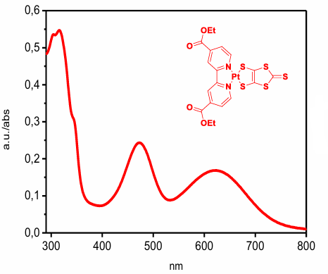
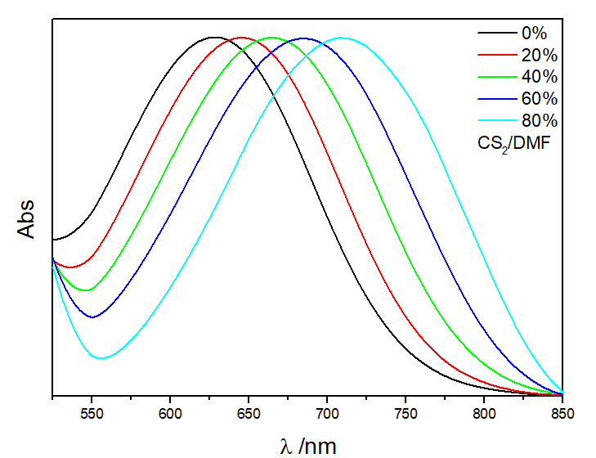
UV–Vis absorption spectroscopy revealed characteristic bands attributable to mixed metal-to-ligand and ligand-to-ligand charge transfer (MLCT/LLCT) transitions, as well as intraligand π–π* excitations. Solvatochromic studies conducted in solvents of varying polarity showed significant shifts in absorption maxima, indicating strong sensitivity of the electronic structure to the surrounding environment. This behavior confirms the pronounced push–pull character of the complexes and supports their suitability for NLO applications.
Figure 2 UV–Vis-NIR absorption spectrum and solvatochromism of the synthesized Pt(DCEtBPY)(DMIT) complex

To further elucidate their electronic features, DFT calculations at the B3LYP level were performed on selected compounds.[3] These calculations provided insight into the frontier molecular orbitals (HOMO and LUMO), their spatial distribution, and associated energy levels. In addition, static polarizability (α) and first hyperpolarizability (β) values were determined, revealing significant NLO responses. In addition, the second-order NLO response was quantified by Hyper-Rayleigh Scattering (HRS) experiments, from which the first-order molecular hyperpolarizability $β$ was extracted, confirming the presence of strong second-order NLO properties in the investigated complexes. The combination of experimental and computational results highlights that these complexes are strong candidates as active materials for integrated quantum photonic devices.


This research was supported by European Innovation Council (EIC) Pathfinder project “ARTEMIS” G. A. n. 101115149. M.A. performed his activity in the framework of the PhD in Innovation Sciences and Technologies at the University of Cagliari, Ita.

REFERENCES

- M. Scalora, M. A. Vincenti, D. de Ceglia, V. Roppo, M. Centini, N. Akozbek, and M. J. Bloemer, (2010) “Second- and third-harmonic generation in metal-based structures”. Physical review, 82, 043828. https://doi.org/10.1103/PhysRevA.82.043828
- Davide Espa a , Luca Pilia b , Salahuddin Attar a , Angela Serpe a , Paola Deplano, (2017) “Molecular engineering of heteroleptic metal-dithiolene complexes with optimized second-order NLO response”. Inorganica Chimica Acta, 470,295-302. https://doi.org/10.1016/j.ica.2021.120731
- Merve Simsek, Omer Tamer, Necmi Dege, Davut Avcı, Hayatullah Mahmoody, Yusuf Atalay, (2024) “A new mixed-ligand zinc(II) complex of 3-hydroxy and 4-chloro substituted pyridine-2-carboxylic acid: Synthesis, characterization, NLO properties and DFT calculation”. Materials Today Communications, 38, 108021. https://doi.org/10.1016/j.mtcomm.2024.108021

